Naïve Bayes Classifier Algorithm
- Naïve Bayes algorithm is a supervised learning algorithm, which is based on Bayes theorem and used for solving classification problems.
- It is mainly used in text classification that includes a high-dimensional training dataset.
- Naïve Bayes Classifier is one of the simple and most effective Classification algorithms which helps in building the fast machine learning models that can make quick predictions.
- It is a probabilistic classifier, which means it predicts on the basis of the probability of an object.
- Some popular examples of Naïve Bayes Algorithm are spam filtration, Sentimental analysis, and classifying articles.

Why is it called Naïve Bayes?
The Naïve Bayes algorithm is comprised of two words Naïve and Bayes, Which can be described as:
- Naïve: It is called Naïve because it assumes that the occurrence of a certain feature is independent of the occurrence of other features. Such as if the fruit is identified on the bases of color, shape, and taste, then red, spherical, and sweet fruit is recognized as an apple. Hence each feature individually contributes to identify that it is an apple without depending on each other.
- Bayes: It is called Bayes because it depends on the principle of Bayes' Theorem.

Bayes' Theorem:
- Bayes' theorem is also known as Bayes' Rule or Bayes' law, which is used to determine the probability of a hypothesis with prior knowledge. It depends on the conditional probability.
- The formula for Bayes' theorem is given as:
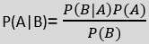
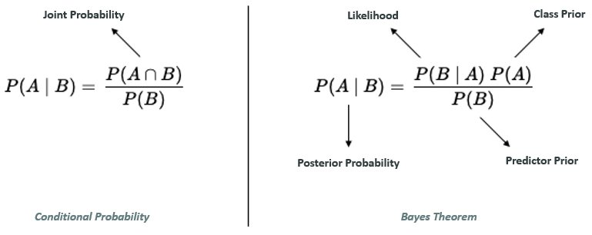
Where,
P(A|B) is Posterior probability: Probability of hypothesis A on the observed event B.
P(B|A) is Likelihood probability: Probability of the evidence given that the probability of a hypothesis is true.
P(A) is Prior Probability: Probability of hypothesis before observing the evidence.
P(B) is Marginal Probability: Probability of Evidence.

Working of Naïve Bayes' Classifier:
Working of Naïve Bayes' Classifier can be understood with the help of the below example:
Suppose we have a dataset of weather conditions and corresponding target variable "Play". So using this dataset we need to decide that whether we should play or not on a particular day according to the weather conditions. So to solve this problem, we need to follow the below steps:
- Convert the given dataset into frequency tables.
- Generate Likelihood table by finding the probabilities of given features.
- Now, use Bayes theorem to calculate the posterior probability.
Problem: If the weather is sunny, then the Player should play or not?
Solution: To solve this, first consider the below dataset:

Advantages of Naïve Bayes Classifier:
- Naïve Bayes is one of the fast and easy ML algorithms to predict a class of datasets.
- It can be used for Binary as well as Multi-class Classifications.
- It performs well in Multi-class predictions as compared to the other Algorithms.
- It is the most popular choice for text classification problems.
- It can handle both continuous and categorical data.
- It is not sensitive to irrelevant data and doesn’t follow the assumptions it holds.
- It is used in real-time predictions.

Disadvantages of Naïve Bayes Classifier:
- The Naive Bayes Algorithm has trouble with the ‘zero-frequency problem’. It happens when you assign zero probability for categorical variables in the training dataset that is not available. When you use a smooth method for overcoming this problem, you can make it work the best.
- It will assume that all the attributes are independent, which rarely happens in real life. It will limit the application of this algorithm in real-world situations.
- It will estimate things wrong sometimes, so you shouldn’t take its probability outputs seriously.

Applications of Naïve Bayes Classifier:
- It is used for Credit Scoring.
- It is used in medical data classification.
- It can be used in real-time predictions because Naïve Bayes Classifier is an eager learner.
- Text classification: The Naive Bayes Algorithm is used as a probabilistic learning technique for text classification. It is one of the best-known algorithms used for document classification of one or many classes.
- Sentiment analysis: The Naive Bayes Algorithm is used to analyze sentiments or feelings, whether positive, neutral, or negative.
- Recommendation system: The Naive Bayes Algorithm is a collection of collaborative filtering issued for building hybrid recommendation systems that assist you in predicting whether a user will receive any resource.
- Spam filtering: It is also similar to the text classification process. It is popular for helping you determine if the mail you receive is spam.
- Medical diagnosis: This algorithm is used in medical diagnosis and helps you to predict the patient’s risk level for certain diseases.
- Weather prediction: You can use this algorithm to predict whether the weather will be good.
- Face recognition: This helps you identify faces.

Types of Naïve Bayes Model:
There are three types of Naive Bayes Model, which are given below:
- Gaussian: The Gaussian model assumes that features follow a normal distribution. This means if predictors take continuous values instead of discrete, then the model assumes that these values are sampled from the Gaussian distribution.
- Multinomial: The Multinomial Naïve Bayes classifier is used when the data is multinomial distributed. It is primarily used for document classification problems, it means a particular document belongs to which category such as Sports, Politics, education, etc.
The classifier uses the frequency of words for the predictors.
- Bernoulli: The Bernoulli classifier works similar to the Multinomial classifier, but the predictor variables are the independent Booleans variables. Such as if a particular word is present or not in a document. This model is also famous for document classification tasks.

